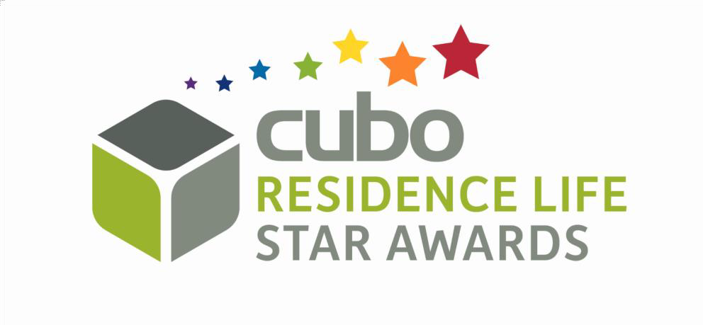
FORM

OF ENTRY

  - Nominees must be working in residence life roles in student in the UK or Ireland.
  - must be nominated by their employer.
  - Maximum two nominations per institution/PBSA organisation, per award category
  - 500 words per entry using the entry form provided.
  - Entries must be submitted by 31st March 2026.

•• NAME:

JOB TITLE:

Please complete the following questions (500 words maximum in total)

Please provide quantitative evidence where possible to support the objectives statements provided.

- WHY DOES THIS EMPLOYEE DESERVE RECOGNITION?

- WHAT HAS BEEN A NOTICEABLE ACHIEVEMENT OF THEIRS?

- IN WHAT WAY HAVE THEY IMPACTED/BENEFITED/INFLUENCED THEIR COMMUNITY?

- WHAT DO COLLEAGUES/RESIDENTS HAVE TO SAY ABOUT THEM?

WHAT OTHER EVIDENCE WOULD YOU LIKE TO SUBMIT TO SUPPORT THIS
NOMINATION?

ENTRY SUBMITTED BY:

JOB TITLE:

EMAIL:

PHONE:

BY SUBMITTING THIS FORM, IF THE ABOVE-NAMED ENTRANT WINS AN AWARD, I AGREE THAT THE INFORMATION ON THIS ENTRY FORM MAY BE USED AS A CAREER CASE STUDY, AND THE ENTRANT'S NAME AND PHOTO CAN BE USED IN AWARDS PUBLICITY.

CLOSING DATE 31st MARCH 2026

